[Tip] Install Two Different Versions Of Firefox On The Same Computer
July 6th, 2010 | 1 Comment | Posted in Software by bharath

Steps:
1. First download and install the wanted Firefox version (Firefox 4.0 Beta 1 in this case). Maak aparte directory aan bv: C:\Program Files (x86)\Mozilla Firefox 4
2. Now go to run (by pressing Windows button + R) command, and click “Browse”.
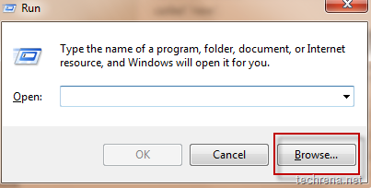
3. Locate the “firefox.exe” from the program files and click “Open”. It will show
"C:\Program Files\Mozilla Firefox\firefox.exe" [If you are not able to see backslashes “\”, see the image below:
in the run command filed.
4. Just append “-p -no-remote” to it and click OK.
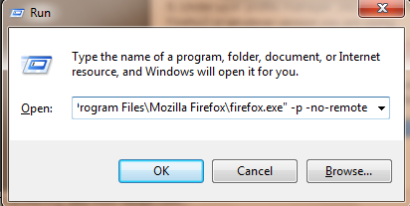
It will open Profile Manager.
5. Under user profile manager, you will just find an entry called “default”. Rename it to something like Firefox3 or whatever version you are using.
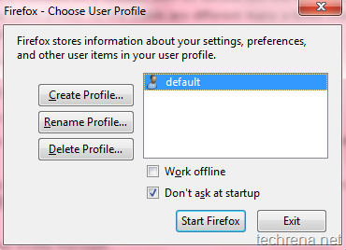
6. Now create a new profile (something like “Firefox4”) through the “Create Profile" Wizard”.
7. So by now you will have two user profiles for Firefox.
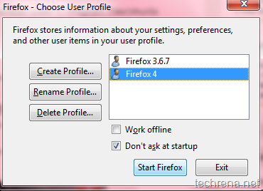
8. Now create two separate shortcuts for both the versions on your desktop.
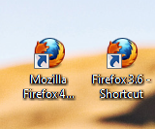
Right-click on the shortcut for the older version and under shortcut target append the following line:
-p Firefox3 -no-remote
[ replace “Firefox3” with whatever your profile name that you had given].
So the shortcut will look like this after editing:
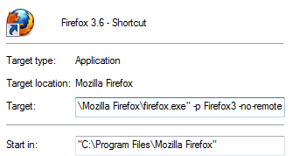
Add the following line to the shortcut for the new version (Firefox 4.0 Beat 1 here):
-p Firefox4 -no-remote
[Replace “Firefox4” with whatever profile name that you have chosen]
The shortcut now appears as shown:
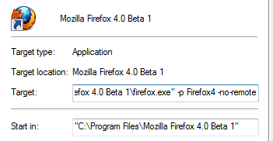
Save the shortcuts and give them appropriate names so that you can distinguish them.
Now you can use these shortcuts to open either of the Firefox versions at ease. However, please be noted that you cannot run the two different versions/builds at the same time.
The trick involved here is all about using Firefox user profiles.Without using profiles, if you try to open the Firefox 3.6 version with Firefox 4.0 beta 1 also installed, then it’ll only going to launch Firefox 4 instead of the other.

