Customize Mozilla Firefox Orange Button, Add or Remove Menus Using Personal Menu (Personal Firefox Button) Extension
http://www.askvg.com/customize-mozilla-firefox-orange-button-add-or-remove-menus-using-personal-menu-personal-firefox-button-extension/

Mozilla Firefox 4.0 and later versions come with new Firefox Orange Button which has replaced old Menubar. It shows all essentials menus in a single place.

Recently our reader "TheAslan" asked us following question in his comment:
Just wondered that is it possible to remove those very annoying "edit, cut, copy, paste..." in my firefox 5.0 menu, i mean that when i click menu button i don't want to see those things there.
The answer is Yes, its possible to remove them. In fact you can remove any desired menu item from Firefox orange button or can add new menu item as shown in following screenshot:
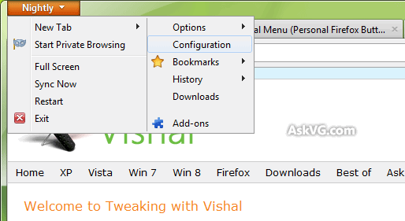
"Personal Menu" (aka Personal Firefox Button) is an excellent extension for Mozilla Firefox 4.0 and newer versions which allows you to add or remove menu items from Firefox orange button.
Once installed, it adds a new menu "Edit this menu" to the orange button. You just need to click on it and you'll get a customize window where you can remove existing menu items or add new items. You can even change their position as well.
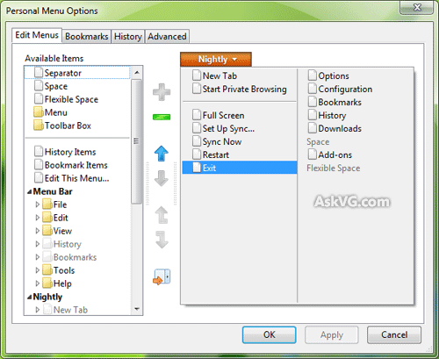
You can also customize Bookmarks and History menus. You can also permanently disable "Menubar" so that it doesn't appear when you accidentally press ALT key.
It also allows you to restore default menus so don't worry if you remove a required menu item.
Ability to add "about:config" and "Restart" options to Orange button is a bonus.
You can download it using following link:
Download Link

