Change the Color and Label for Orange Button in Firefox 4

http://www.trishtech.com/internet/change_color_and_label_of_orange_button_in_firefox_4.php

1
This page was last updated on April 26, 2011
The Firefox browser has undergone a complete design change and in the version 4 it shows a orange colored button on the top-left. This orange colored button is labeled Firefox and when you click on it the menu appears. Some people do not like the orange color of this button. If you do not like the orange color of this button, then with a little workaround you can change not only its color but also its label as you wish. Here is how :
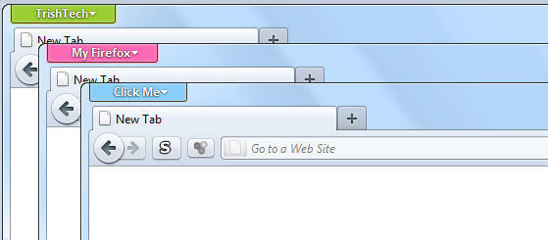
- Press the keyboard shorcut Windows logo key + R to open the Run dialog.
- Type %appdata%\Mozilla\Firefox\Profiles in the Run dialog and hit the Enter key on your keyboard.
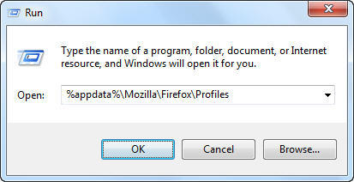
- You would find a folder with name ending in .default. On my computer, I have jfmbqk7u.default. Open this and create a subfolder named chrome. Inside the chrome folder create a new file named userChrome.css. It may be possible that you already have this file.
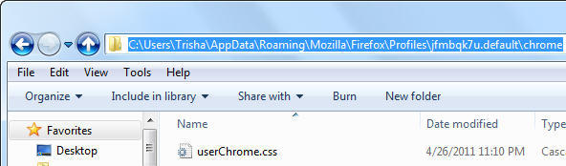
- Open userChrome.css in your favorite text editor (like Notepad).
- If you created a new userChrome.css file, copy-paste the following lines to it and save it
@namespace url("http://www.mozilla.org/keymaster/gatekeeper/there.is.only.xul");
#appmenu-button
{
background: #9acd32 !important;
}
#appmenu-button dropmarker:before {
content: "TrishTech" !important;
}
#appmenu-button .button-text {
display: none !important;
}
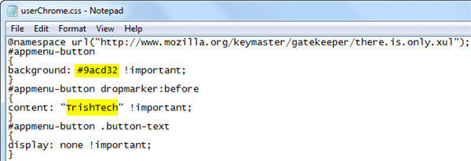
If you already had a userChrome.css on your system, then just append the above lines to it - excluding the first line (the one that starts with @namespace).
- This changes the button text (label) to TrishTech and the button color to #9acd32 (HTML color code for yellow green). You can choose your own button label and your own button color. To see a list of popular HTML color codes, you can visit http://www.w3schools.com/HTML/html_colornames.asp.
- Restart the Firefox web browser for the changes to take effect.

